**CREATION OF SCHOOL MANAGEMENT IN SALESFORCE**

Creating a school management system in Salesforce involves leveraging Salesforce's robust features to handle various aspects of school administration, such as student enrollment, attendance tracking, grade management, communication, and more. Here's a high-level overview of how you can approach building a school management system in Salesforce:

**1. Data Model:**

* **Students:** Create a custom object to store student information (name, contact details, address, etc.).
* **Teachers:** Create a custom object for teacher details.
* **Classes:** Another custom object for class information (class name, schedule, etc.).
* **Subjects:** Custom object to store subjects taught in the school.
* **Enrollments:** A junction object to establish many-to-many relationships between students and classes.

**2. Automation:**

* **Workflows:** Set up workflows for automating tasks such as sending notifications for missing assignments or upcoming exams.
* **Process Builder:** Create processes for tasks like enrollment approval workflows or sending reminders for fee payments.
* **Flows:** Use flows for more complex processes, like handling student transfer requests.

**3. Communication:**

* **Email Templates:** Create email templates for various communications like event invitations, report card distribution, etc.
* **Mass Email:** Utilize Salesforce's mass email feature for sending newsletters or important updates to parents and staff.

**4. Attendance Tracking:**

* **Custom Objects/Fields:** Create custom objects/fields to track daily attendance for students and teachers.
* **Validation Rules:** Implement validation rules to ensure accurate attendance data entry.

**5. Grade Management:**

* **Custom Objects/Fields:** Create custom objects/fields to store grades for different subjects and assignments.
* **Reports and Dashboards:** Utilize Salesforce's reporting capabilities to generate grade reports, class performance summaries, etc.
* **Chatter:** Enable Chatter for real-time discussions between teachers, students, and parents regarding grades and assignments.

**6. Integration:**

* **External Systems:** Integrate with external systems for features like online payments, library management, or learning management systems.
* **APIs:** Use Salesforce APIs to connect with third-party applications securely.

**7. Security:**

* **Profiles and Permissions:** Set up profiles and permissions to control access based on roles (students, teachers, administrators).
* **Field-Level Security:** Ensure sensitive information is protected using field-level security settings.
* **Data Encryption:** Utilize Salesforce's built-in encryption mechanisms for data security.

**8. Mobile Access:**

* **Salesforce Mobile App:** Leverage the Salesforce mobile app for on-the-go access to the school management system.
* **Custom Mobile Apps:** If necessary, develop custom mobile apps using Salesforce Mobile SDK for specific functionalities.

**9. User Training and Support:**

* **Training:** Provide training sessions to staff for effective use of the Salesforce system.
* **Documentation:** Create detailed documentation for using different features and processes.
* **Support System:** Set up a support system for addressing user queries and issues promptly.

**10. Testing and Iteration:**

* **Testing:** Rigorous testing of the system to ensure all functionalities work as intended.
* **User Feedback:** Gather feedback from users (teachers, students, parents) and iterate on the system based on their input.

Remember, Salesforce provides extensive documentation and a strong community where you can find support and additional resources while building your school management system.

**PHONE NUMBER**

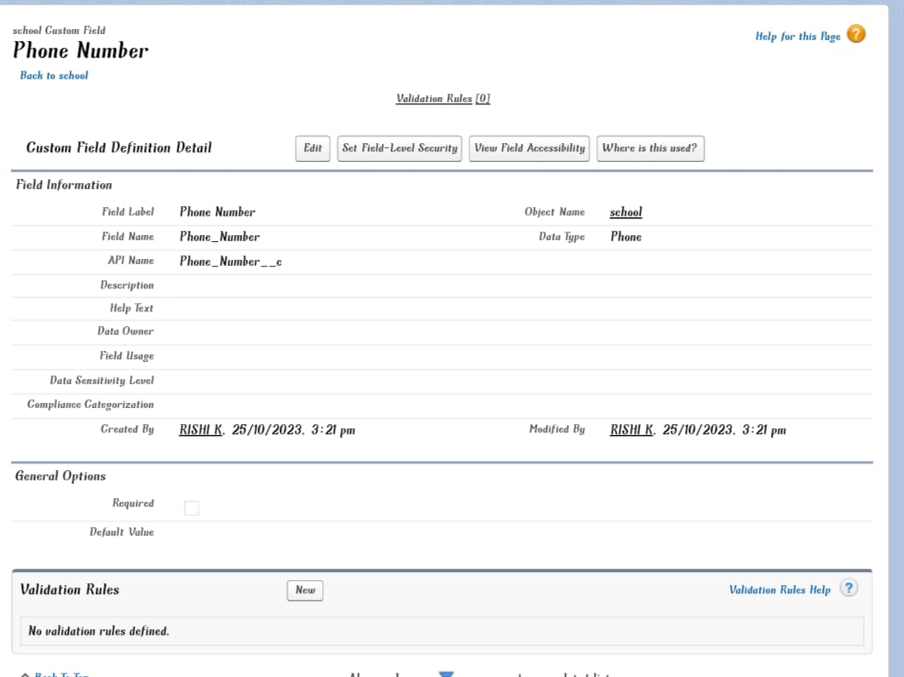

**SCHOOL WEBSITE**

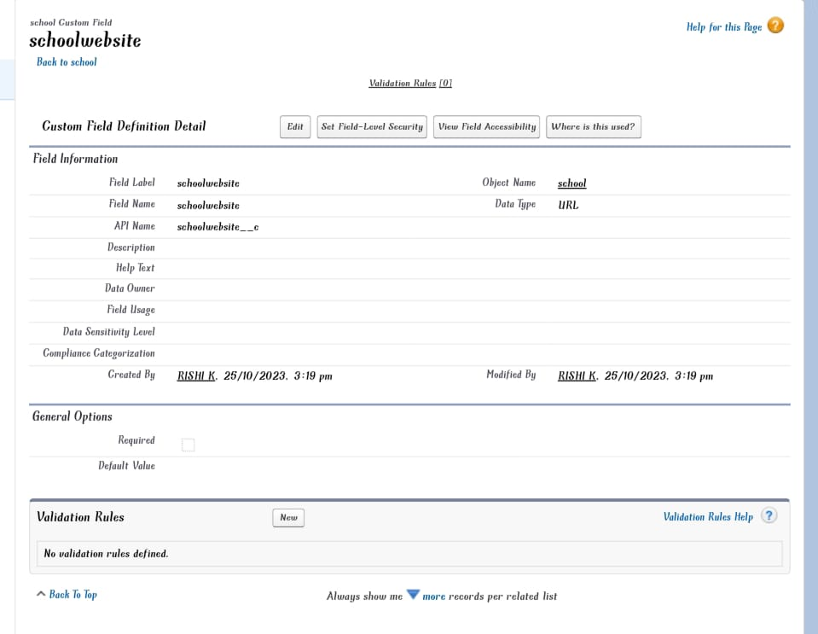

**DISTRICT**

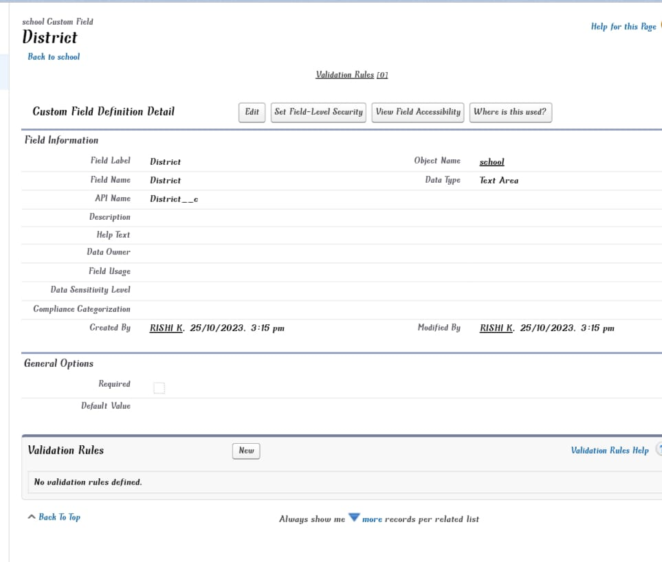

**STATE**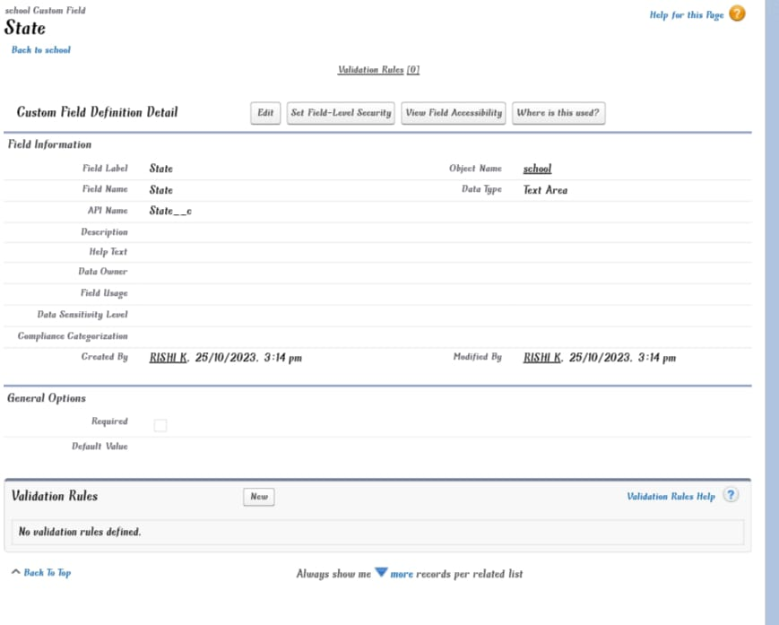

**ADDRESS**

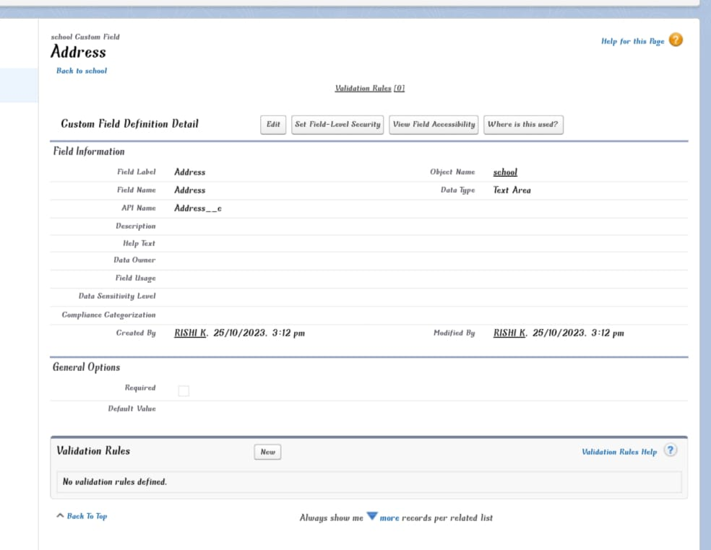

**SCHOOLS**

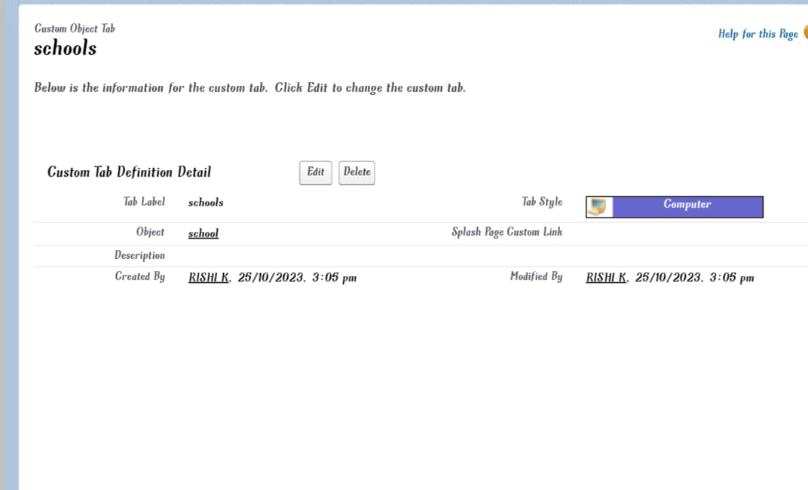

**PARENTS**

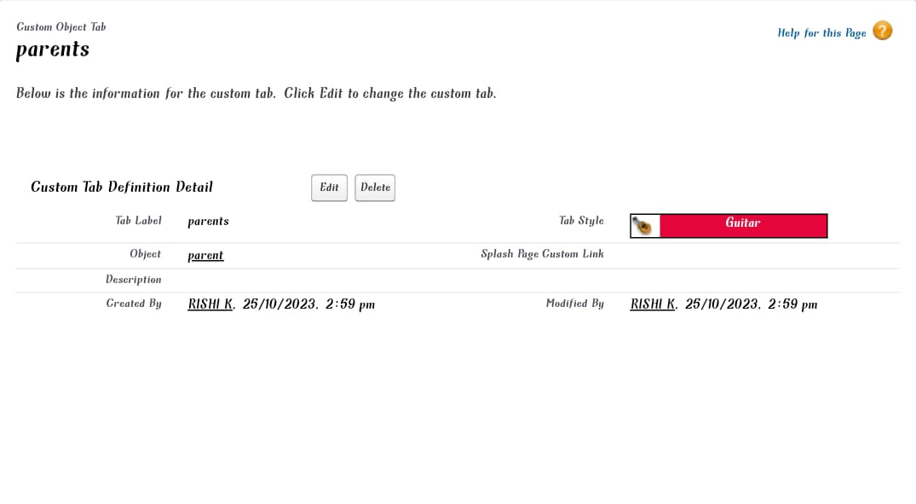

**STUDENTS**

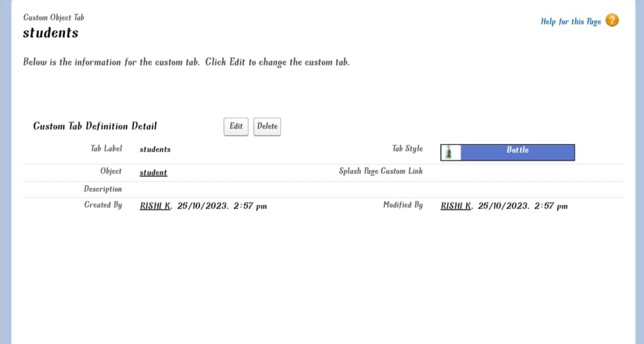

**Fields & Relationships**

**SCHOOL**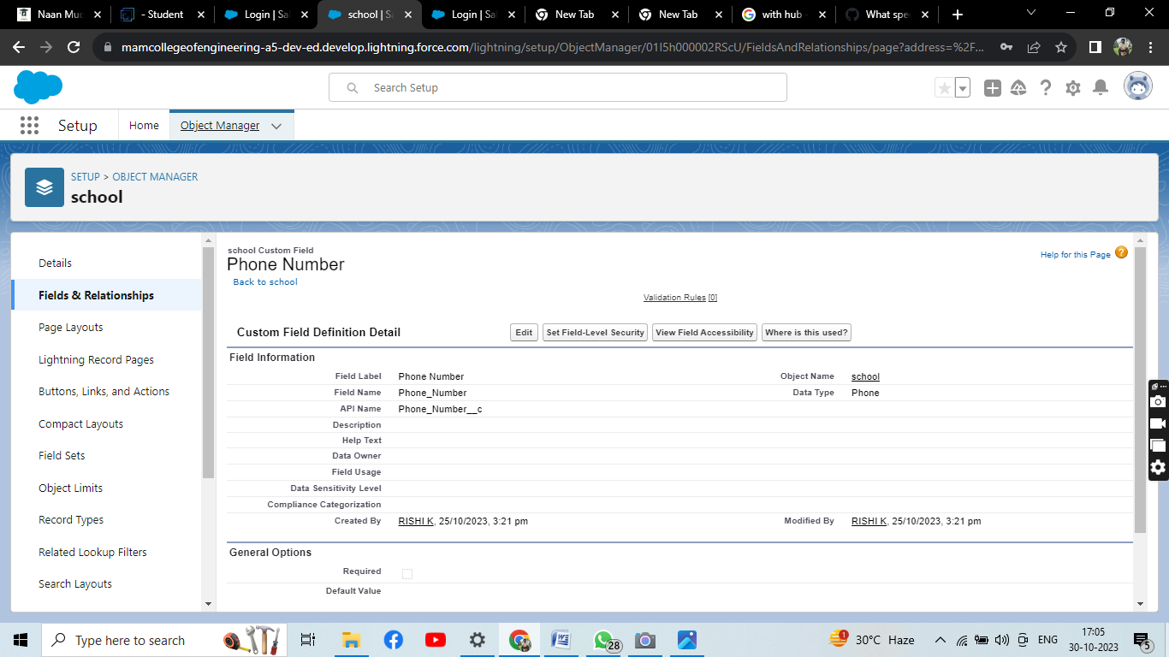

**STUDENTS**

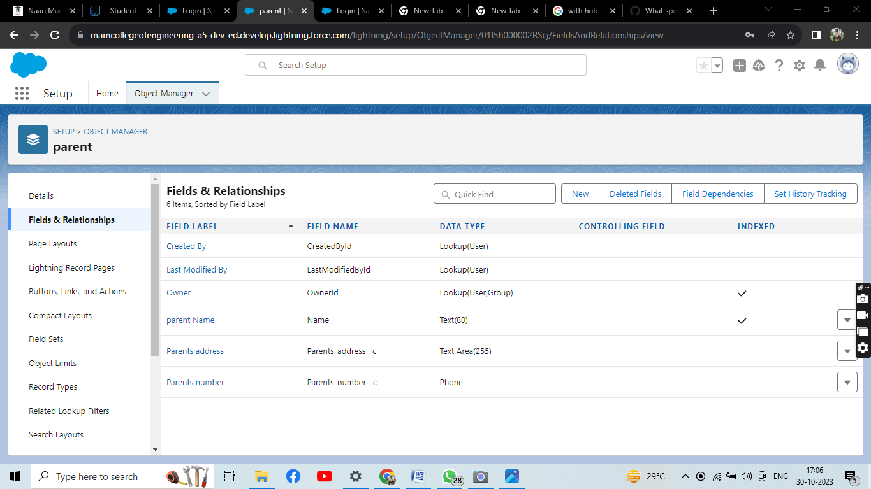

PARENTS



**FLOWS**

